Azeotrope detection procedure

Formation of new azeotropes is usually not desired when selecting an entrainer for extractive distillation processes. Figure 1 shows an illustration of how the azeotropes look like on a graphical aspect using an isobaric x-y diagram.
Figure 1: illustrative x-y diagrams for maximum (left) and minimum (right) boiling azeotropes

As can be seen in Figure 1, the relative volatility is on each side of unity at the extremities of the composition. As such, this can be used to detect potential azeotropes in a mixture.
Consider a mixture of A-B, the azeotrope detection is done as shown in the following:
$$\log{{\left.α_{AB}\right|}_{x_{A}=0}}* \log{{\left.α_{AB}\right|}_{x_{A}=1}}$$ | (1)
$$\log{{\left.\frac{K_{A}}{K_{B}}\right|}_{x_{A}=0}}* \log{{\left.\frac{K_{A}}{K_{B}}\right|}_{x_{A}=1}}$$ | (2)
$$K_{B}{\left.​\right|}_{x_{A}=0}=K_{A}{\left.​\right|}_{x_{A}=1}=1$$
$$\log{{\left.K_{A}\right|}_{x_{A}=0}}* \log{{\left.\frac{1}{K_{B}}\right|}_{x_{A}=1}}$$ | (3)
$$\log{{\left.K_{A}\right|}_{x_{A}=0}}* -\log{{\left.K_{B}\right|}_{x_{A}=1}}$$ | (4)
$$\log{{\left.\frac{y_{A}}{x_{A}}\right|}_{x_{A}=0}}* -\log{{\left.\frac{y_{B}}{x_{B}}\right|}_{x_{A}=1}}$$ | (4)

Consider the following:
$$y=x*γ*\frac{P^{*}}{P^{0}}$$ | (6)

Then we get
$$\log{{\left.\frac{x_{A}*γ_{A}*P_{A}^{*}}{x_{A}*P^{0}}\right|}_{x_{A}=0}}* -\log{{\left.\frac{x_{B}*γ_{B}*P_{B}^{*}}{x_{B}*P^{0}}\right|}_{x_{A}=1}}$$ | (7)
$$\log{{\left.γ_{A}*\frac{P_{A}^{*}}{P^{0}}\right|}_{x_{A}=0}}* -\log{{\left.γ_{B}*\frac{P_{B}^{*}}{P^{0}}\right|}_{x_{A}=1}}$$ | (8)

Consider the following system: acetone-water using unifac
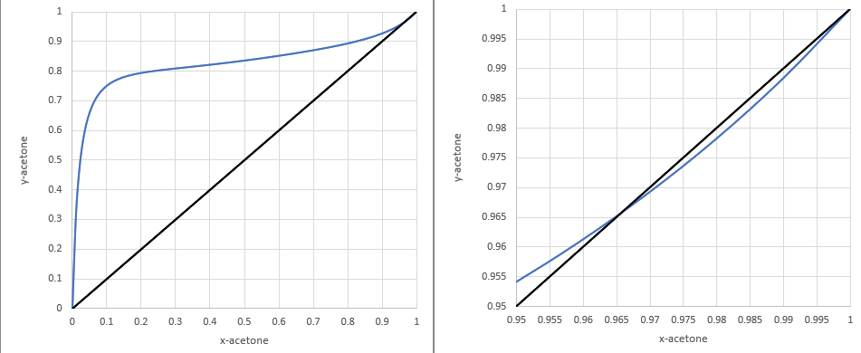
Figure 2: x-y diagrams for Acetone-water system (left) and a zoomed in version (right)

The data are found in
x_{A} | x_{B} | y_{A} | y_{B} | γ_{A} | γ_{B} | P*_{A} | P*_{B} | T
0.0 | 1 | 0 | 1 | 12.21763 | 1 | 0.36323 | 0.10133 | 373.15
0.0101 | 0.9899 | 0.30931 | 0.69069 | 11.10183 | 1.00051 | 0.27948 | 0.0.07066 | 363.24
0.9899 | 0.0101 | 0.98827 | 0.01173 | 1.00034 | 6.92591 | 0.10113 | 0.01699 | 329.09
1 | 0 | 1 | 0 | 1 | 7.40828 | 0.10132 | 0.01704 | 329.15

The azeotrope detection is done as in the following
$$\log{{\left.γ_{A}*P_{A}^{*}\right|}_{x_{A}=0}}* -\log{{\left.γ_{B}*P_{B}^{*}\right|}_{x_{A}=1}}$$
$$⇓$$
$$\log\left(12.21763*\frac{0.36323}{0.101325}\right)* -\log\left(7.40828*\frac{0.01704}{0.101325}\right)$$
$$⇓$$
$$\log\left(\frac{4.43}{0.101325}\right)* -\log\left(\frac{0.12}{0.101325}\right)$$
$$⇓$$
$$-0.64$$
It works!!!

The data:
 | A | E | B
dp12 | 1 | 1E-07 | 1E-07
dp13 | 0.9 | 0.1 | 1E-07
dp14 | 0.8 | 0.2 | 1E-07
dp15 | 0.7 | 0.3 | 1E-07
dp16 | 0.6 | 0.4 | 1E-07
dp17 | 0.5 | 0.5 | 1E-07
dp18 | 0.4 | 0.6 | 1E-07
dp19 | 0.3 | 0.7 | 1E-07
dp20 | 0.2 | 0.8 | 1E-07
dp21 | 0.1 | 0.9 | 1E-07
dp22 | 1E-07 | 1 | 1E-07

$$α_{A}^{AE}(x_{22})=γ_{A}*P_{A}^{*}$$
$$α_{E}^{AE}(x_{12})=\frac{1}{γ_{E}*P_{E}^{*}}$$
$$az_{AE}=\log{α_{A}^{AE}(x_{22})}*\log{α_{E}^{AE}(x_{12})}$$

 | A | E | B
dp23 | 1E-07 | 1E-07 | 1
dp24 | 1E-07 | 0.1 | 0.9
dp25 | 1E-07 | 0.2 | 0.8
dp26 | 1E-07 | 0.3 | 0.7
dp27 | 1E-07 | 0.4 | 0.6
dp28 | 1E-07 | 0.5 | 0.5
dp29 | 1E-07 | 0.6 | 0.4
dp30 | 1E-07 | 0.7 | 0.3
dp31 | 1E-07 | 0.8 | 0.2
dp32 | 1E-07 | 0.9 | 0.1
dp33 | 1E-07 | 1 | 1E-07

$$α_{B}^{BE}(x_{33})=γ_{B}*P_{B}^{*}$$
$$α_{E}^{BE}(x_{23})=\frac{1}{γ_{E}*P_{E}^{*}}$$
$$az_{BE}=\log{α_{B}^{BE}(x_{33})}*\log{α_{E}^{BE}(x_{23})}$$

 | A | E | B
dp1 | 1 | 1E-07 | 1E-07
dp2 | 0.9 | 1E-07 | 0.1
dp3 | 0.8 | 1E-07 | 0.2
dp4 | 0.7 | 1E-07 | 0.3
dp5 | 0.6 | 1E-07 | 0.4
dp6 | 0.5 | 1E-07 | 0.5
dp7 | 0.4 | 1E-07 | 0.6
dp8 | 0.3 | 1E-07 | 0.7
dp9 | 0.2 | 1E-07 | 0.8
dp10 | 0.1 | 1E-07 | 0.9
dp11 | 1E-07 | 1E-07 | 1

$$α_{A}^{AB}(x_{12})=γ_{A}*P_{A}^{*}$$
$$α_{B}^{AB}(x_{1})=\frac{1}{γ_{B}*P_{B}^{*}}$$
$$az_{AB}=\log{α_{A}^{AB}(x_{12})}*\log{α_{B}^{AB}(x_{1})}$$

